# Experiment 1

**Aim: Design of All-in-One logic gate circuits.**

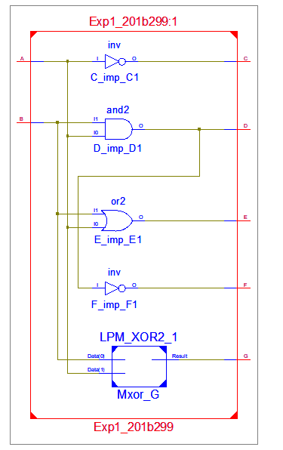**Exercise 1:** Design two inputs and five outputs All-in-One logic gate circuit shown in Fig.1. Write the VHDL code in data flow style of modeling.

**Design code:**

library IEEE;

use IEEE.STD_LOGIC_1164.ALL;

entity Exp1_201b299 is

Port ( A : in STD_LOGIC;

B : in STD_LOGIC;

C : out STD_LOGIC;

D : out STD_LOGIC;

E : out STD_LOGIC;

F : out STD_LOGIC;

G : out STD_LOGIC);

end Exp1_201b299;

architecture Dataflow of Exp1_201b299 is

begin

C <= not A;

D <= A and B;

E <= A or B;

F <= A nand B;

G <= A xor B;

end Dataflow;

**Test Bench code:**

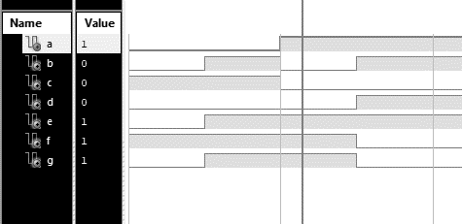

A <= '0'; B<= '0';

wait for 100 ns;

A <= '0'; B<= '1';

wait for 100 ns;

A <= '1'; B<= '0';

wait for 100 ns;

A <= '1'; B<= '1';

wait for 100 ns;

**Exercise#2:** Design two inputs and one output All-in-One logic gate diagram shown in Fig.2. Write theVHDL code in behavioral style of modeling using (i) if-then-else (ii) case-when.

**Design code (if –then-else):**

library IEEE;

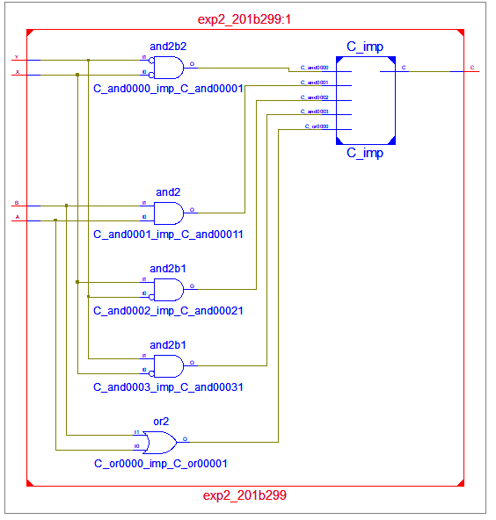use IEEE.STD_LOGIC_1164.ALL;

entity exp2_201b299 is

Port ( A : in STD_LOGIC;

B : in STD_LOGIC;

C : out STD_LOGIC;

X : in STD_LOGIC;

Y : in STD_LOGIC);

end exp2_201b299;

architecture Behavioral of exp2_201b299 is

begin

process (A,B,X,Y)

begin

if(X = '0' and Y = '0') then

C <= A and B;

elsif (X = '1' and Y = '0') then

C <= A or B;

elsif (X = '0' and Y = '1') then

C <= A nor B;

else

C <= A nand B;

end if;

end process;

end Behavioral;

**Test Bench code:**

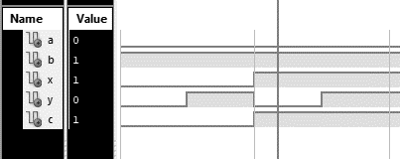A <= '0'; B<= '1';

X <= '0'; Y<= '0';

wait for 100 ns;

A <= '0'; B<= '1';

X <= '0'; Y<= '1';

wait for 100 ns;

A <= '0'; B<= '1';

X <= '1'; Y<= '0';

wait for 100 ns;

A <= '0'; B<= '1';

X <= '1'; Y<= '1';

wait for 100 ns;

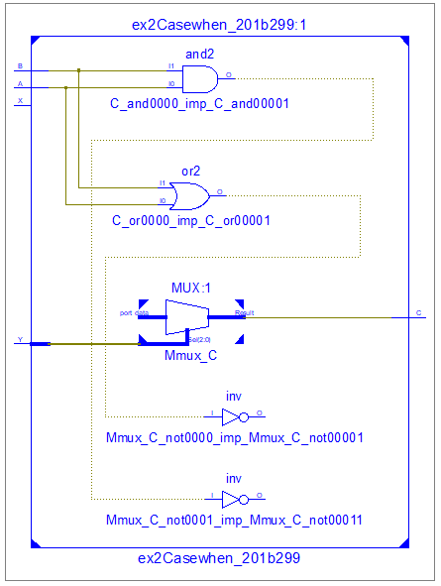**Design code (case-when):**

library IEEE;

use IEEE.STD_LOGIC_1164.ALL;

entity ex2Casewhen_201b299 is

Port ( A : in STD_LOGIC;

B : in STD_LOGIC;

C : out STD_LOGIC;

X : in STD_LOGIC;

Y : in STD_LOGIC);

end ex2Casewhen_201b299;

architecture Behavioral of ex2Casewhen_201b299 is

begin

process(X,Y,A,B)

variable SEL: std_logic_vector(1 downto 0);

begin

SEL := X & Y;

case SEL is

when "00" => C <= A and B;

when "01" => C <= A or B;

when "10" => C <= A nand B;

when others => C <= A nor B;

end case;

end process;

end Behavioral;

**Test Bench code:**

A <= '0'; B<= '1';

X <= '0'; Y<= '0';

wait for 100 ns;

A <= '0'; B<= '1';

X <= '0'; Y<= '1';

wait for 100 ns;

A <= '0'; B<= '1';

X <= '1'; Y<= '0';

wait for 100 ns;

A <= '0'; B<= '1';

X <= '1'; Y<= '1';

wait for 100 ns;